[1]

IP Controlled Robot Receptionist/Guide through Raspberry Pi (June 2016)

Mina Khan, *student, CIIT*, M. Bilal Jamil

*Abstract*— The main idea is to build an intelligent autonomous robot using Raspberry Pi whose utility will be demonstrated in a receptionist/guide at the premises of COMSATS Institute of Information Technology(CIIT) or at any other organization for example as a hotel receptionist. This robot is programmed to receive and guide the guest arriving at the institution to a predefined destination by overcoming all obstacles in its way and then safely returning to its initial specific position. The approach of building a robot receptionist/guide can help attract more people to CIIT, giving the institution more recognition by introducing interactive robots into the environment. The robot will perform its task in a wireless networked environment controllable from a remote location within the range of a wireless router. This approach will allow a distant user to monitor and control the robot more efficiently and effectively unlike a wired system where small distance control is a major limitation. The robot will be assigned a static IP address and it will guide to a path to let’s say the library of CIIT so the library will also be assigned a static IP address. The robot will then follow this IP address through path planning defined by Open Street Maps and Google Maps. The product will require short range transmitter/receiver design as well as control through network communication along with circuit design, python programming, system integration, testing and debugging, networking and communication.

*Index Terms*— Intelligent Machines in Robotics (IMR), Artificial Intelligence (AI), autonomous robots, Raspberry Pi robots, sensor system integration, robot guide.

1. INTRODUCTION

A

s we are living in 21st century, Science has advanced everything at an alarming rate. So in order to include Information Technology and built our project at an advanced level, we are using a robot as a guide/receptionist which can lead a certain individual to a certain place rather than conducting the job our-self. This pushes us out of our

comfort zone as this is not a simple task but can be one of the state art robots made at CIIT. The robot is made keeping in mind that it doesn’t contradict the three basic laws of robotics as stated by 20th-century author in 1941, in his novel *I, Robot*. These laws are as follows:

1. No human being should be harmed or injured by the robot.
2. Apart from contradicting the First Law, a robot is obliged to comply with the commands specified to it by human beings.
3. Without contradicting with the First or Second Law, a robot should do anything in its power to protect its individual existence. [2]

The main significance of this project can be explained easily as this robot will run wirelessly over internet using IP protocols and Wi-Fi USB Dongle which doesn’t use any wired media thus this is an exceptionally advanced approach towards robotics. Moreover the robot follows a path which is programmed on it using Python language and it won’t deviate from its path as long as the coordinates of the maps are set right.

During the four year course of our degree, we have taken several hardware and software courses where we learned about implementing different solutions to a problem. In this project, the major area of work is not to make a full fledge high cost robot but the major motive is to implement the idea of moving the robot to the pre-defined destination keeping in mind least possible budget. A system is developed and implemented to direct the robot from IP. The core component of the system is a library i.e. software platform. In order to operate, control and make the robot functional through design and testing, it is essential to build up a user interface (UI). The command will be given by the end user to the server control program on the UI which will assess the command and send it to the IP network by the functions in the Network Library. The Network Library present at the robot’s end receives the command and forwards it to the robot control program which interprets the command yet again and drives the robot. As communication with the robot is essential part of this project, communication system is set to be bidirectional so it has the capability of getting data from the robot. Next, the maps are implemented through the map script which is taken from various map websites like “Open Street Maps” and “Google Maps” and changing those scripts according to our area and setting the coordinates for the respective place which in our case is the path from CIIT Electrical Engineering department till the student library.

There are two types of obstacles which can be faced during the mobility of robots. They are static and dynamic obstacles. Static obstacles exist in the environment which is not in motion and are more predictable for example “a staircase or a wall” whereas dynamic obstacles are those which are in motion in the surrounding and can occur at any unpredictable time. A decent robot will be such which can combine the solution of both types of obstacles and avoid collisions. For such purpose the robot is built with extremely high-quality choice of sensors to evade the problem. A sensor is a device that measures some attribute of the world. Being one of the three primitives of robotics (besides planning and control), sensing plays an important role in robotic paradigms. There are a number of sensors which are used to overcome this problem. We used IR sensors, Digital Sensors, Infrared Sensors, Sonar Modules, Proprioceptive sensors, Tilt sensors and PIR (passive infrared sensor) for this project. The robot therefore is programmed in a way such that if the robot is near an obstacle it automatically moves back and forth and then move on its way to a desired position.

## Brief history

A robot in a nutshell is a machine designed to accomplish a task. When talking about robots, we are actually talking about machines that use their programming to make decisions. A robots consist of components that are required to carry out each step in the decision making and performing the task i.e. they have sensors for input, control systems for decision making and end effectors for output. Developing each of these components can be very challenging. Sensors should be able to detect things like images and sounds effectively, control system should make decisions in order to make the sensors and effectors work together and effectors should be flexible and fast enough to perform the tasks we need them to do. Talking about how industrial robot development got where it is today we need to know why Industry was a good place to start and why robots first became useful over there. Since factory work can be repetitive and requires lifting heavy objects, this makes it a perfect fit for a machine, therefore the world’s first ever industrial robot UNIMATE was installed on general motors production line in New Jersey in 1961weighing nearly a metric ton, and it was basically a giant robotic arm. Its instructions programmed in a huge magnetic drum told the arm to stack and weld hot pieces of metal over and over again. Soon other car companies started generating their own robotic arms but the arms weren’t particularly flexible and were ultimately difficult to program. So then the robotic arm called IRB 6 came along in 1974. Developed by the Swedish engineering firm ABB, It was the first electric industrial robot that was controlled by a micro computer; it had 16 Kilobytes (KB) of RAM, it was programmable, it could display four whole digits with its LEDs and could performs tasks like polishing steel tubes. You can give robot all the programming you want, but it could only perform limited tasks that too inefficiently if it doesn’t have the ability to see and judge. This problem gave birth to a new field referred to as the ‘artificial intelligence (AI)’ these days. Initially it was incredibly difficult to make the programs interact with the real world as it involved a whole new dimension of decision making which robots at that time couldn’t simply manage. Robot’s vision is not just about viewing pictures but it’s actually about recognizing objects so that they can react to situations in real time. By the late 1970s the engineers introduced digital image processing to the robots making them more intelligent. They had developed new algorithms that allowed cameras to recognize edges and shapes by using visual cues like highlights and shadows but all this research was restricted to research labs. This all changed in 1981 when the system called ‘consight’ was implemented once again by the general motors’ factory in which three separate robots used visual sensors to pick out and sort six different kinds of auto parts as 1400 parts per hour moved on the conveyer belt. In the next two decades technology kept improving and industrial robots were able to see better, move faster, carry heavier loads and make more decisions. Some industrial robots then headed towards the more general purpose use like the humanoid robot called Wabot I also known as the first full-scale humanoid robot developed by the researchers at WASEDA university in Japan in 1973. It had arms, legs, and a vision system, and also had the ability to walk and talk. [1]

## Block Diagram

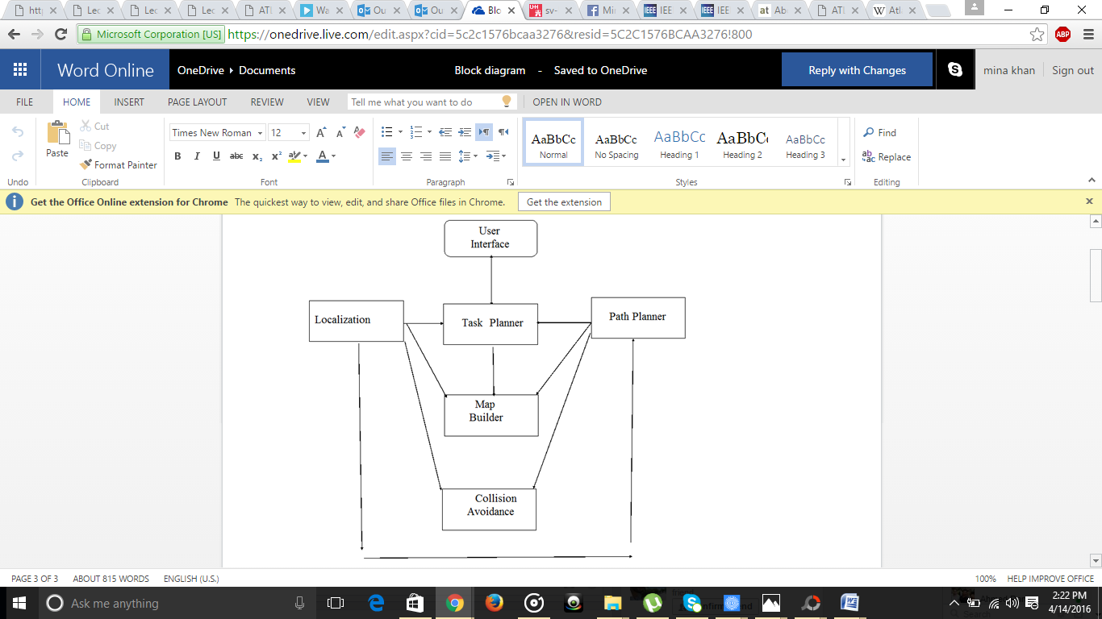

Figure 1: Block Diagram

In the above block diagram the basic working process cycle chart is shown. User interference for this project is very critical as the user will directly interact with the robot and the process of turning the raspberry pi on/off, setting up the display on laptop and assigning the tasks for the robot and how they will be performed.   
The path planner will define the complete path for the robot on which it will move. For example if we want to move the robot from the EE department of CIIT to CS department, this particular path planner will be followed and on it the tasks will assigned respectively. 

Localization of any robot is used to determine where it is currently, usually pointing the origin or a specific destination and if the robot is lost we can find where it’s located.   
All localization techniques usually provide with the following two pieces of concept:-

* Current location of the robot in some atmosphere?
* Current orientation in that same atmosphere?

The above first concepts can be used in some form of Cartesian and Polar coordinates or latitudes and longitudes. Hence using this part with the path planner will carve out a map on which the robot will move autonomously with simultaneously indicating where it is going after every second.  This map will be taken from either Open Street Maps or Google Maps. After specifying the map the obstacle avoidance part will come which will inform the robot if there is an obstacle in front of it or on it sides with the help of ultrasonic sensors.

# Hardware architecture

## Raspberry Pi working and stipulations

Raspberry Pi is a complete computer, yet at an affordable price. This can be used to build systems which can easily be configured, yet have very high utility. This absolves the users of many minor issues related to communication and networking allowing them to think at bigger level. This device is very flexible and powerful as compared to the other microcontrollers. It gives a complete Graphical User Interface and we can interact with it just like a personal computer i.e. through Input/output (I/O) devices e.g. Keyboard, Mouse, etc. As soldering is complicated and obsolete method as compared to advanced technologies today, for this reason we are making a robot which is soldering free which hence minimizes chances of error and hardware damage. We used raspberry Pi B+ for our project with the following specifications:

1. Silicon Core Number: BCM2835
2. Family: BCM2xxx
3. ARM11 Architecture
4. Advanced GPU with Open GL ES 2.0, OpenVG, and 1080p30 H.264 high-profile decode
5. HDMI
6. Ethernet
7. 2 USB ports
8. 512MB RAM
9. Power 5v, 2Amperes
10. 4x2.0 USB Connectors
11. Max clock frequency: 700MHz
12. 40 GPIO PINS

## Setting up and installing the Raspberry Pi:

Step 1: Open browser and visit the official website of raspberry Pi(https://www.raspberrypi.org/)

Step 2: Click on “Downloads” and then click on “NOOBS”. Now download this operating system by following the instruction.

Step 3: Now store this file on a blank MicroSD card by connecting it to the computer

Step 4: Once NOOBS has been stored, remove the SD card from the computer and insert it in the reader slot of the Raspberry Pi.

Step 5: Connect the Raspberry Pi to a monitor screen through High Definition. Multimedia Interface (HDMI) cable by inserting it to the HDMI port on the Raspberry Pi.

Step 6: Now connect Mouse and Keyboard using the USB ports on the Raspberry Pi.

Step 7: Lastly, connect the power lead to the Raspberry Pi- this can be any standard android phone charger. Now connect this to the socket.

Step 8: On plugging in, the Raspberry Pi will start automatically and NOOBS will start booting up. It will show on the screen several installation options from which we will chose the recommended “Raspbian package” and install it

Step 9: Once the installation is finished, you will be asked to reboot now. Click on “yes” and once it restarts, the Raspberry Pi will be compatible and working with the Raspbian Desktop which enables our Raspberry Pi to be compatible with several software applications like web browsers, python programming software etc and hence Raspberry Pi is now ready to use.

## Making the Raspberry Pi wireless

Open control panel and select **Network and Sharing Center** settings and will navigate to **Change Adapter Setting**

Right click on the Wireless Adapter and click on **Properties**

1. From the **Sharing** Tab and we will select the “**Allow other network users to connect through this computer’s Internet connection”** checkbox
2. Now we will right click the Lan Adapter and hit Properties. After selecting the IPV4 option we will check if there is some dynamic IP address there for example: **192.168.137.1**
3. Turn the Raspberry Pi on and connect one end of the LAN Cable to the Raspberry Pi and the other end to the PC. We will see the status messages **Identifying** and eventually we will get **Unidentified network.**
4. Precisely after the above steps open up **command** prompt and type in:  
   **ping raspberrypi.net. Now we will be able to ping the Pi.**
5. We will use the other software putty, after proper installation we will open it and then set the Host Name as: raspberrypi.mshome.net and hit connect. We can also use the IP address of the Pi which is mentioned in the above explained ping prompt at **192.168.137.149.**
6. Now with the help of all the softwares installed we can see the login prompt. Now enter **pi as login** and **raspberry as password** and then press **Enter.**
7. **We can test by pinging a website let’s say** [www.google.com](http://www.google.com) **by giving the command “ping www.google.com”**We have now successfully synced the pi with our laptop while making a wifi connection.

## Setting up the robot kit

At the initial stages, we used the simple drive mechanism in order to implement several testing stages conveniently. This mechanism was further enhanced in the final stage by mounting it on a bigger robot body. Following is the detailed description of the component and how they were used:

* Power source:

The robot consists of several electrical components which need power to function. So most importantly, the robot board as to be installed with batteries giving it the liberty to move instead of power chord which will contribute in limiting robots movements. After testing each component requirement, a battery of 12V 12Ah was installed the robot.

* H-Bridge:

An H-Bridge consists of four transistors in an ‘H’ pattern that allows the voltage supply to get linked with the load which in this case are two motors used to drive each wheel, with high levels of current. By changing the path of this curren flow, the motor was able to turn in both directions. The main objective of installing an H-Bridge on the robot board is to control the speed of the motors through PulseWidth Modulation (PWM) signals from the multipoint control unit (MCU) that deals with the path of motors without any glitch or twisting of the wires of the motors. The microcontroller sends a PWM signal of a particular time period and width. The figure illustrates the timing of the pulses.

* DC Gear Motor:

The DC motor is equipment that converts electrical energy into mechanical energy. The motor rotates forward if current flows from its positive terminal towards the negative, and vice versa. The gears attached to it increase the torque and power of these motors. Therefore, with a reduction of power applied, more work is done through these motors with the help of gears. The speed of the motors can be altered by changing the input voltage or the duty cycle. To do this we need H- Bridge, which is controlled by the PWM through the processor. [1] The DC gear motors used for the purpose of this robot are rated 24VDC with a stall current of 2A when motors are at maximum load. A voltage of 12V is applied to the motors and the speed of both the motors is matched by adjusting different duty cycles for each motor.

TABLE I

longitude latitude values

|  |  |  |  |
| --- | --- | --- | --- |
| Location | Latitude | Longitude | |
|  |  | |
| EE dept | 33.651089 75.156414 | |
|  |  | |
|  |  | |

Ciit library 33.649509 73.154732

* Sensors

In order to add the flavor of artificial intelligence and making the robot independent sensing capabilities are added to robot. Taking budget into account, several sensing devices were selected and installed to the robot board that is near to ground surface in order to detect static and dynamic obstacles and path sensing and the required tasks that should be carried out by the robot.

* Ultrasonic Range Finder

The ultrasonic range finder is used to sense objects that are at a distance without the robot actually colliding with the objects to sense them. It utilizes sound pulses to measure distance just like the way how bats and submarines find their way around. By emitting an ultrasonic pulse and timing to hear an echo, it accurately estimates the distance of the object that is nearby. The figure illustrates how a transmitter is emitting sound waves which are reflected to the receiver, and then the MCU calculates the distance by observing the time taken for the echo to rebound.

We have used HC-SR04 out of several options of range finders as illustrated in the next section.

* HC-SR04 Sonar Sensor:

The Sonar Sensor provides measurement without get in touch which ranges from 2cm - 400cm. The ranging accuracy can reach to 3mm. The module includes ultrasonic transmitters, receiver and control circuit. Following are the specifications of the sonar sensor used:

|  |  |
| --- | --- |
| **Working Voltage** | DC 5V |
| **Working Current** | 15mA |
| **Working Frequency** | 40Hz |
| **Max Range** | 4m |
| **Min Range** | 2cm |

# Map Implementation for path following

For this project, maps are used to figure out the longitudes and latitudes of the destination we are interested in. For this purpose, the website www.latlong.net was used where the location was specified and its longitude and latitudes were achieved. Following is the table showing these values:

# Making the robot autonomous

## We will make the robot autonomous by syncing the open street or Google maps with the robot with the help of a GPS USB or tracker. In order to achieve this task we can also use a GPS sensor. After this we will setup specific IP addresses to each location on the basis of which the robot will know where it has to go and with the help of the path planning algorithm along with the map builder and localizations the robot can easily specify how and where it has to go.

With the help of the GPS data we can program specific waypoints for the robot to follow by the help of which it will go to its location and this will also help it to keep a safe path to its destination without bumping on obstacles or on the wrongpath.  
Even if there comes an obstacle the ultrasonic sensor will detect it and guide the robot to move away from it. Apart from ultrasonic sensors we can also use IR sensors [16].

# Parallel states of the robot

The mechanism of the robot is divided into four states. Each state with the help of Raspberry Pi is running side by side and all the variables used in these states are kept global so several functions can access these variables to perform the specified task.

## State 1:

State 1 is involves setting the head of the robot. The angle of the desired destination (set_head(angle)) is compared with the angle of current destination. So in order to set the head, this state compares both values and takes actions accordingly so both these values coincide and form a line of sight. The robot goes into state 1 when the current angle with an uncertainty of 10 degrees of destination angel is achieved.

## State 2:

State two checks if distance from obstacle is greater than 70m meters, the robot keeps moving. As soon as the distance becomes less than 70m there is an indication of obstacle and the robot stops for 3 seconds and goes to state 3 to perform the next steps in case of occurrence of obstacle.

## State 3:

State 3 checks that after the obstacle is detected, where will it be more feasible to turn. So a check has been implemented where it checks the distance from an obstacle in both left or right direction. Then realizes where the distance from obstacle is more and the robot moves over there. For example, we have an open road at right of the obstacle and on left there is a wall as another obstacle. So the robot moves to the open road. Once it moves there, it has to set its head again to stay focused at the destination therefore goes to state 1 again and the whole process is repeated.

## State 4:

State 4 is when the distance from the destination is now zero i.e. the destination has been reached. Now the robot is stopped and “destination reached” is printed.

# GUI of the robot receptionist

The project operates the robot through a GUI that is designed on the laptop of the user controlling it. It consists of two option, automatic movement and manual movement. Automatic movement consists of the buttons to the pre-specified locations. When one of the buttons is pressed, the latitudes and longitudes and angles of the distance specified is set. And the robot is automatically operates to reach to that destination. Other option is of manual movement, where specific keys of the robot are assigned to the buttons up, down, right and left and this way a user can also operate the robot. Following is the screenshot of the designed GUI:

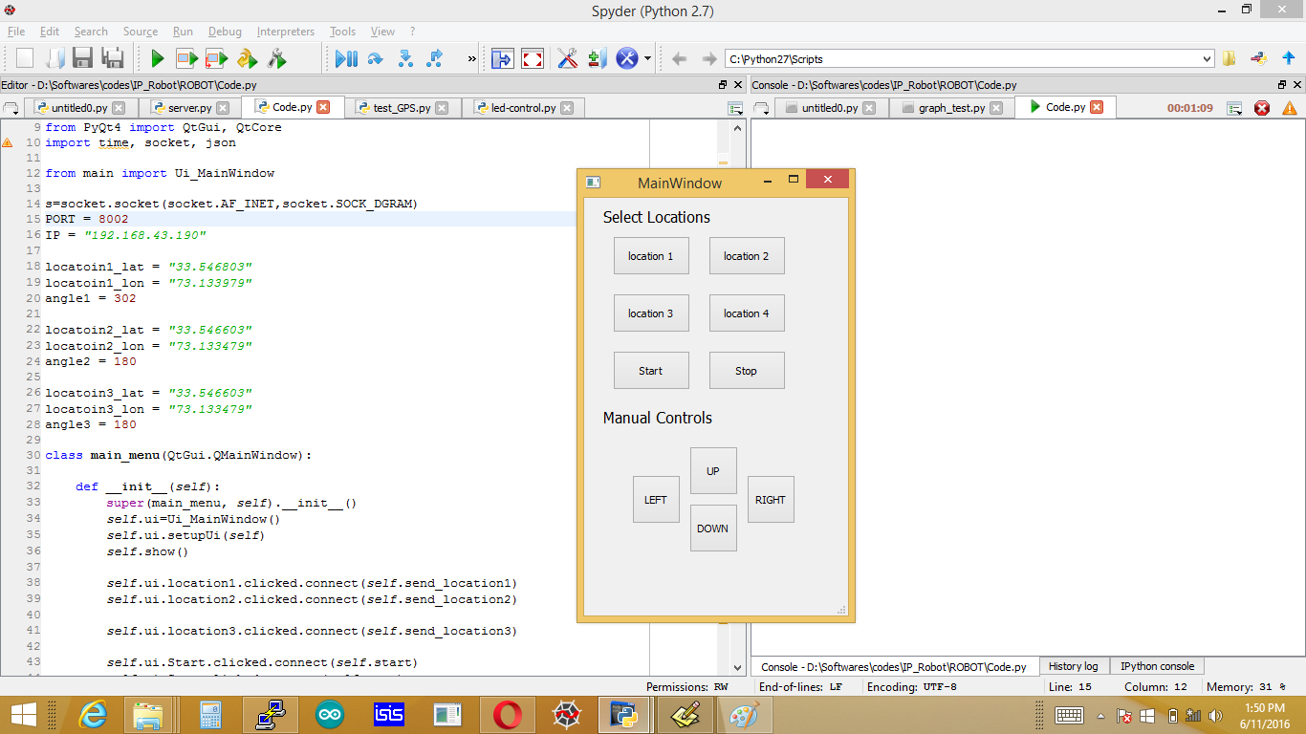  
**Figure 2: GUI of Robot Receptionst**

# Conclusion

We successfully implemented the robot receptionist at the premises of CIIT making the environment more Hi-tech. With the help of Raspberry Pi, the huge visions could be implemented without exceeding the budget.

*ACHNOWLEDGMENT*

We are thankful To Almighty Allah, who showered us with His blessings and gave us strength to complete this project. We also take this opportunity to express our profound gratitude and deep regards to our family and friends for their exemplary guidance and monitoring, financial support and constant encouragement throughout the course of this project.

 We also take this opportunity to express a deep sense of gratitude to our Mentor Sir Riaz Hussain, Assistant Professor at COMSATS University Islamabad, for the valuable information and guidance, which helped us in completing this project through various stages.

references

[1] V. Ivan, "allaboutvic," [Online]. Available: <https://allaboutvic.com/about/>. [Accessed 1 April 2016].

[2]I. Asimov, I, Robot, Gnome Press, 1950.

[4]"History of ASIMO Robotics | ASIMO Innovations by Honda", *Asimo.honda.com*, 2016. [Online]. Available: HYPERLINK "<http://asimo.honda.com/asimo-history/>" <http://asimo.honda.com/asimo-history/> . [Accessed: 01- Apr- 2016]

[5]S. Michieletto, "NAO Robot Simulation for Service Robotics Purposes," *IEEE,* no. 10.1109/EMS.2013.80, pp. 477 - 482, 2013.

[6]S. Thrun, "MINERVA: a second-generation museum tour-guide robot," *IEEE,* 1999.

[7] R. Beira, "Design of the robot-cub (iCub)," *IEEE,* no. 10.1109/ROBOT.2006.1641167, pp. 94 - 100, 2006

[8] Kokoro Company Ltd, 1 feburary 1984. [Online]. Available: <http://www.kokoro-dreams.co.jp/english/about/about_data.html>. [Accessed 1 April 2016].

[9] "PETMAN (Protection Ensemble Test Mannequin) Humanoid Military Robot," army-technology, [Online]. Available:http://www.army-technology.com/mediapacks/online/about-us-online.html. [Accessed 2 April 2016].

[10] The Next Generation of Boston Dynamics' ATLAS Robot

[11]E. Upton, *NEW PRODUCT LAUNCH! INTRODUCING RASPBERRY PI MODEL B+*. 2014. [Online]. Available: HYPERLINK "<https://www.raspberrypi.org/blog/introducing-raspberry-pi-model-b-plus/>" <https://www.raspberrypi.org/blog/introducing-raspberry-pi-model-b-plus/> . [Accessed: 30-Mar-2016].

[12] The Pi4J Project, *Expansion Header*. 2015

[13] I. Kakakhel, "Pakistan Defense," 10 Feburary 2013 . [Online]. Available: http://defence.pk/threads/60-universities-in-pakistan-working-on-robotics-technology.259262/. [Accessed 3 April 2016].

[14]A. B. M. Hofmeier, 9 11 2004. [Online]. Available: <http://www.abmh.de/en/papers/lsbu/fyp/doc/FYPInterimReport.HTML/>. [Accessed 31 3 2016].

[15]"RASPBERRY PI 1 MODEL B+," RASPBERRY PI FOUNDATION, Feburary 2015. [Online]. Available: https://www.raspberrypi.org/products/model-b-plus/. [Accessed 5 April 2016].

[16]"ERII," january 26 2015. [Online]. Available: https://kushrami.wordpress.com/2015/01/26/how-to-load-raspberry-pis-desktop-on-your-laptop-screen/. [Accessed 5 April 2016].

1. This work is submitted as a Partial Fulfillment for the award of Degree Bachelor of Science in Electrical (Computer) Engineering at COMSATS university Islamabad supervised by Dr. Riaz Hussain Assistant professor COMSATS University Islamabad.